Wireshark Lab 4 – IP

Chibunze uzo

1. The IP address of my computer is 10.0.0.164

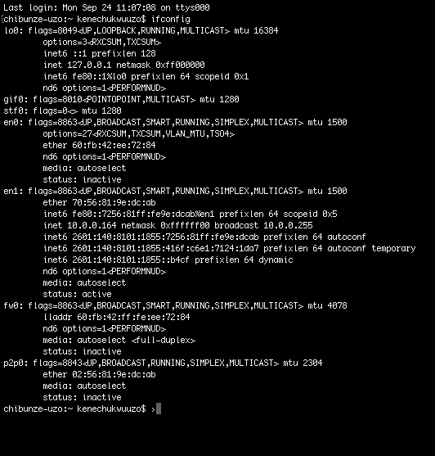

1. The total length of the datagram is 484 bytes

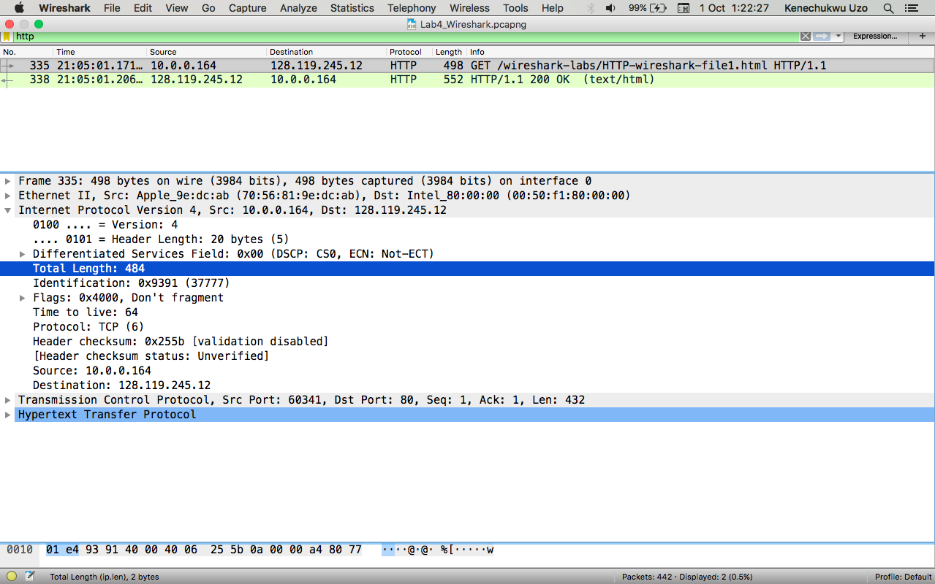

1. No, the IP datagram has not been fragmented, because the fragment offset : 0

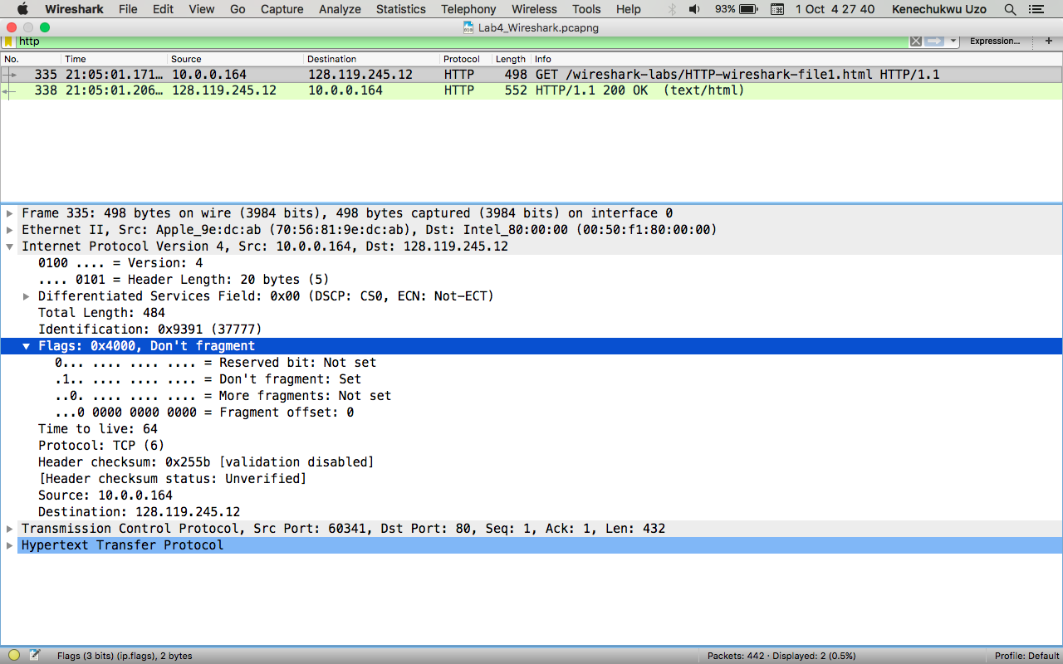

1. There are 20 bytes in the IP header

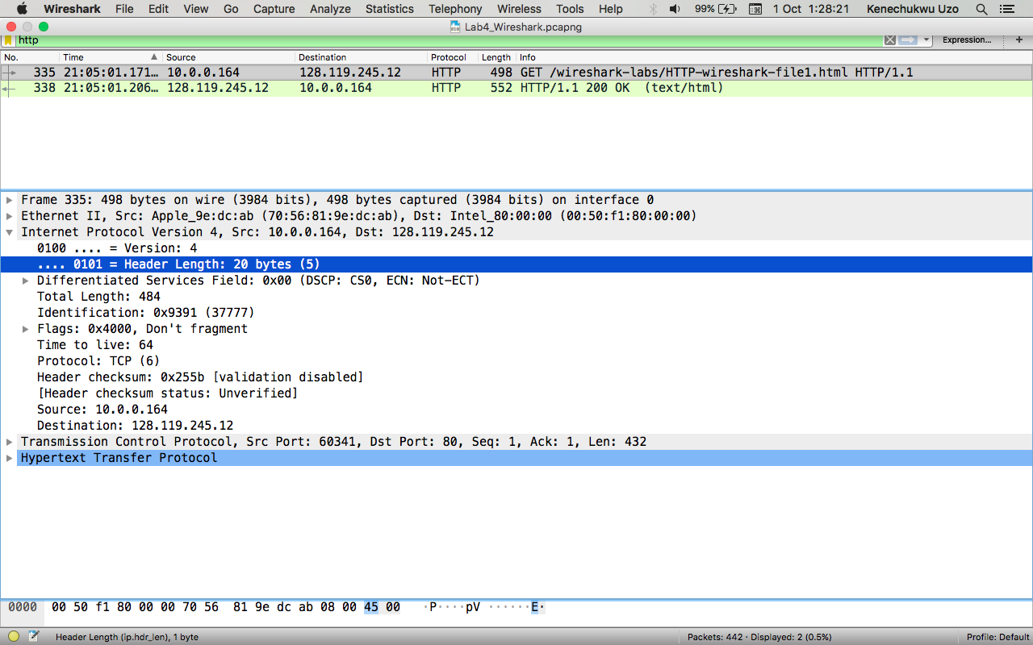

1. There are 464 bytes in the payload of the IP datagram

Explanation

Total length of datagram = 484, whereas

Header length = 20 bytes

Therefore, payload of the IP datagram = 484 – 20

= 464 bytes

